13.01.2021

|  |
| --- |
| **Two-minute read # 4 - Why do Startups fail? Some New Perspectives** |

**Word of the day:** The ‘value proposition’ is a bundle of benefits that a venture offers to its customers for which they would prefer the product or service of a venture over those of the competitors.

***John C Maxwell - “Fail early, fail often, but always fail forward.”*** Success is not about avoiding failure. Success is achieved through learning from failure. If one achieves success without failing, chances are s/he is overly lucky. Every successful story has many failures preceding the success. Achieving success becomes more manageable if you can fail early, meaning that if failure has to happen, let it happen early so that you can save time and resources for the next attempt. Endlessly pursuing an idea is like flogging a dead horse. Fail often and learn from each failure to gain maturity. When reminded of his failures, Thomas Alva Edison famously said, “I have not failed. I’ve just found 10,000 ways that won’t work.” But the most important part of failure is to fail forward. Maxwell explains that one must learn from failure and move forward with that knowledge not to repeat the same mistake. If you stop trying again with more conviction, you really fail. On the flip side, if you are overly passionate about your idea and do not accept the fact that it would not take you anywhere, you are destined to fail forever (many refers to the TATA Nano car project in this regard). Always fail forward, not to fail for good.

***Charlie Munger once said, figuratively - “All I Want to Know Is Where I’m Going to Die so I’ll Never Go There.”*** That puts today’s topic in the right perspective. If we know why startups fail, we will avoid making the same mistakes and be successful. Data collated by cbinsights.com by analyzing the post-mortems of 101 failed ventures bring to light the real causes of their failure. The most significant revelation of this data is that the majority of these causes can be averted through appropriate pre-emptive actions. For example, 42% of the startup failures occurred because they produced and tried to sell things that nobody wanted to buy. Ideally, startups must onboard customers early on and get the idea and the early products validated by potential users before sinking in a lot of resources and time. The second most failures occurred due to running out of money. A more in-depth analysis of the companies failing due to this reason would reveal that majority of them neglected financial prudence. Many of them mismanaged finances, while others failed to approach investors in time primarily because they did not make a meaningful cash flow projection to know when they would run out of money. Most of these failures could have been averted by being frugal, disciplined, and planning in advance. We shall discuss some relevant real cases in the class later. Placed below is the summary of the findings by cbinsight.com for your ready reference.

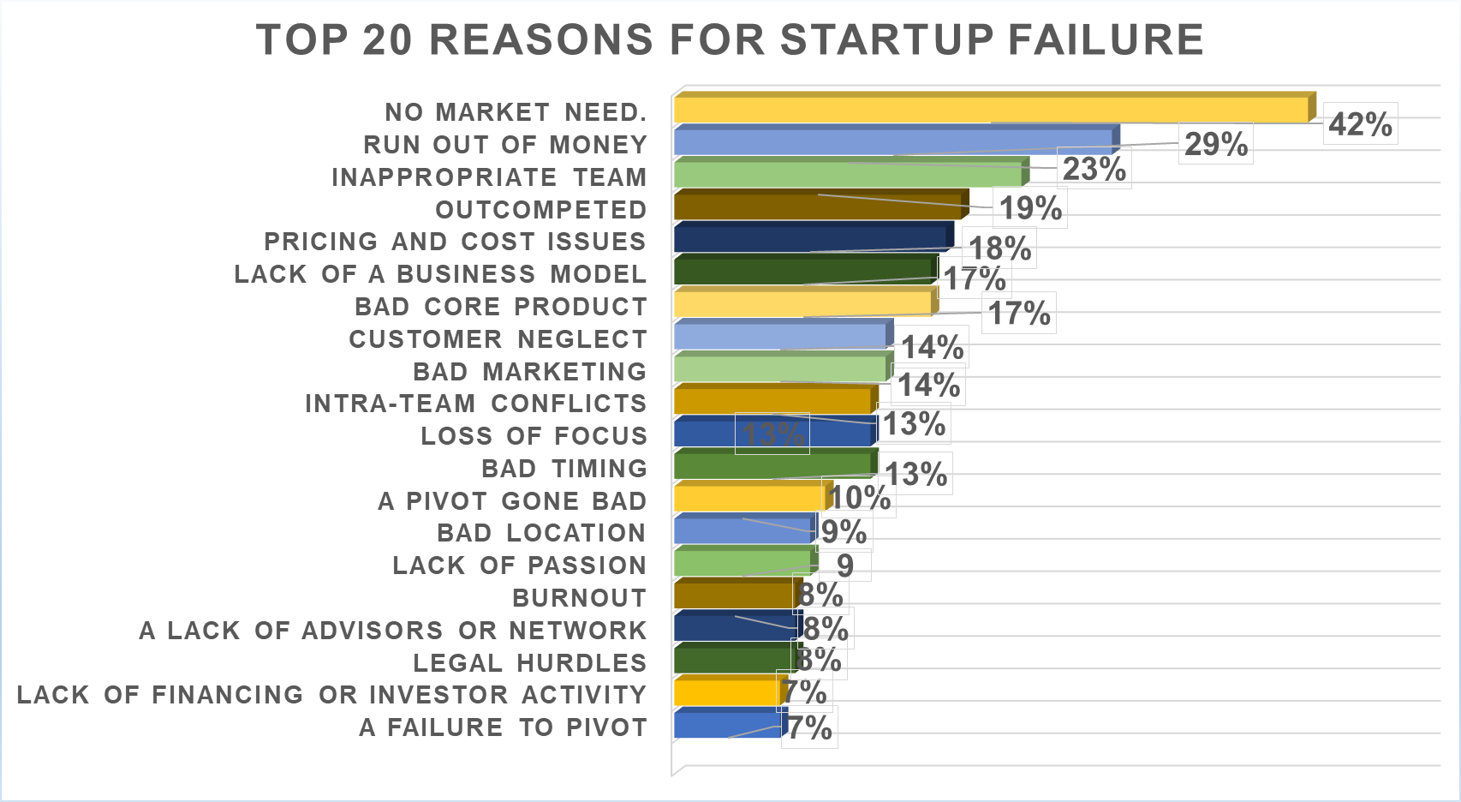

One significant and frequent cause of failure is team incompatibility, disharmony, incongruence, disunity. The team must have the same passion, share the same vision, must work collectively and synchronously in unison on the same mission. Though data show a small percentage of startups failing because of team inappropriateness, a more in-depth look at all failed companies will reveal elements of team incompatibility leading to a great deal of stress and finally pushing toward failure. Though there is no time-tested formula, strangers do not make a good team. A team of 2 to 3 (maximum four) members appears to work far better than a one-member team or teams of more than four members. A team should have members with complementary skills to fill all the knowledge gaps. Some experience in a startup in any capacity or as a profit-center head in an established company may be of great help. Persons with moral or ethical laxity must be avoided no matter what value they bring.

The ‘founders’ dilemma’ leads to many failures. It is the unwillingness of founders to recognize their lack of skill in business process management and refusing to relinquish the management control to professionals (Noam Wasserman). Starting a business is one thing; managing growth is another. It requires an entirely different set of skills that people learn through experience. Early success tends to make some founders complacent. They need to understand that success is not a goal or a destination that one may wrongly think to have achieved; success is a process or a journey that continues as long as the venture lives. You lose focus and free-fall over a precipice.

**References**

Failing Forward - John C. Maxwell, HarperCollins Focus, 2007.

Fail Fast, Fail Often: How Losing Can Help You - Ryan Babineaux & John Krumboltz, Penguin, 2013

<https://www.cbinsights.com/research/startup-failure-reasons-top/>

The Founder’s Dilemma by Noam Wasserman, HBP, 2008